300-400#STEERS | 5.05-6.05 | 300-400#HEIFERS | 4.30-5.25
400-500# STEERS | 4.65-5.35 | 400-500# HEIFERS | 4.20-4.80
500-600# STEERS | 4.05-4.65 | 500-600# HEIFERS | 3.80-4.30
600-700# STEERS | 3.70-4.10 | 600-700# HEIFERS | 3.25-3.75
700-800# STEERS | 3.52-3.95 | 700-800# HEIFERS | 3.25-3.60
800-900# STEERS | 3.25-3.58 | 800-900# HEIFERS | 3.15-3.45
Top Bulls | 1.90-2.08 | Medium Bulls | 1.50-1.85
800-900# Bulls | 3.10-3.40 | 900-1000# Cows | 3.00-3.35
Young Cows | 1.85-2.20 | Top Cows | 1.62-1.74
Medium Cows | 1.20-1.55 | Low-yielding Cows | 1.35 Below
^{NEXT WEEK:} Thursday, 25th – Sheep and Goat Sale – Sheep and Goats ONLY!! – 200 hd lambs (Crawford), 40 boer kid goats (Olathe).

Saturday, September 27th – Cattle Sale – All classes – Feeder calf special – Customer Appreciation Sale @ 11 AM – COME FOR A FREE LUNCH! 15 hd Steer calves (Gunnison). 35 mixed yearlings (Colbran). 20 hd mixed calves (Norwood)

UP COMING SALES:
Thursday, October 2nd – Regular Sale – Feeder Calf Special
Saturday, October 4nd – Special Tack & Horse Sale
Thursday, October 9th – Regular Sale – Feeder Calf Special
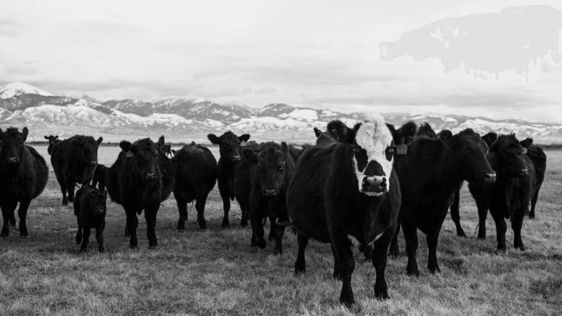
Thursday, October 16th – Regular Sale – Feeder Calf Special

